Sponsor a school

Name of the School : ZPHS (G)BIBIPET
Address : ZPHS (G)BIBIPET, District: KAMAREDDY,

Principal Name : T.Prasanna Laxmi.
Contact Phone number :

Classes : nursery to class 10th
Strength : 140

About School w/ photos : ZPHS (gitls)BIBIPET school was established in 1940 's as TELUGU MEDIUM Primary school .It was called as BALABADI at that time. After 40 years it was shifted to present location. The school was upgraded to SSC in the academic year (1993-94). Since then our school was centered several students from surrounding "10"villages, MainlyJanagama,Mandapoor,Ambaripet,Yadavaram,Tujalpoor,Malkapoor,Issanagar,Upperpally, Ramreddypalle etc .

Number of students of our school were settled in government services as well as in private sectors too.This school building was very old now but still it runs with 9 old rooms which were in dilapidated condition.
Our school strength was around 450 in past years .
In June 2019 english medium started with 6th class and thereafter it will upgrade to 10th class year by year.That's why it needed more class rooms than before.
Now the strength of the school is 140. In the future it may reach past strength .
Total sanctioned teachers posts are 14 but 5 posts are falling vacant.
We are very proud to state that, many students of our school are secured admissions in prestigious institutions like III -basara, govt polytechnic colleges,and Reputed Engineering colleges. To fullfil the growing needs of our increasing strenth, the government has been providing basic needs still we need advance technology like Laptops,Audio sound system,purified water facility.We request "PFI" to provide the above mentioned electronic items to import education techniques to our students

Government sanctioned 2 rooms but those were not enough.we have no library room,science lab,girls waiting room,and games room.
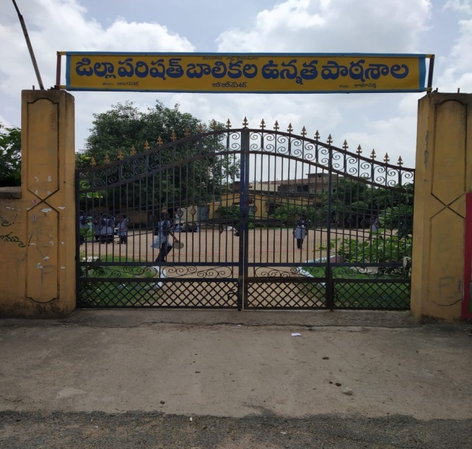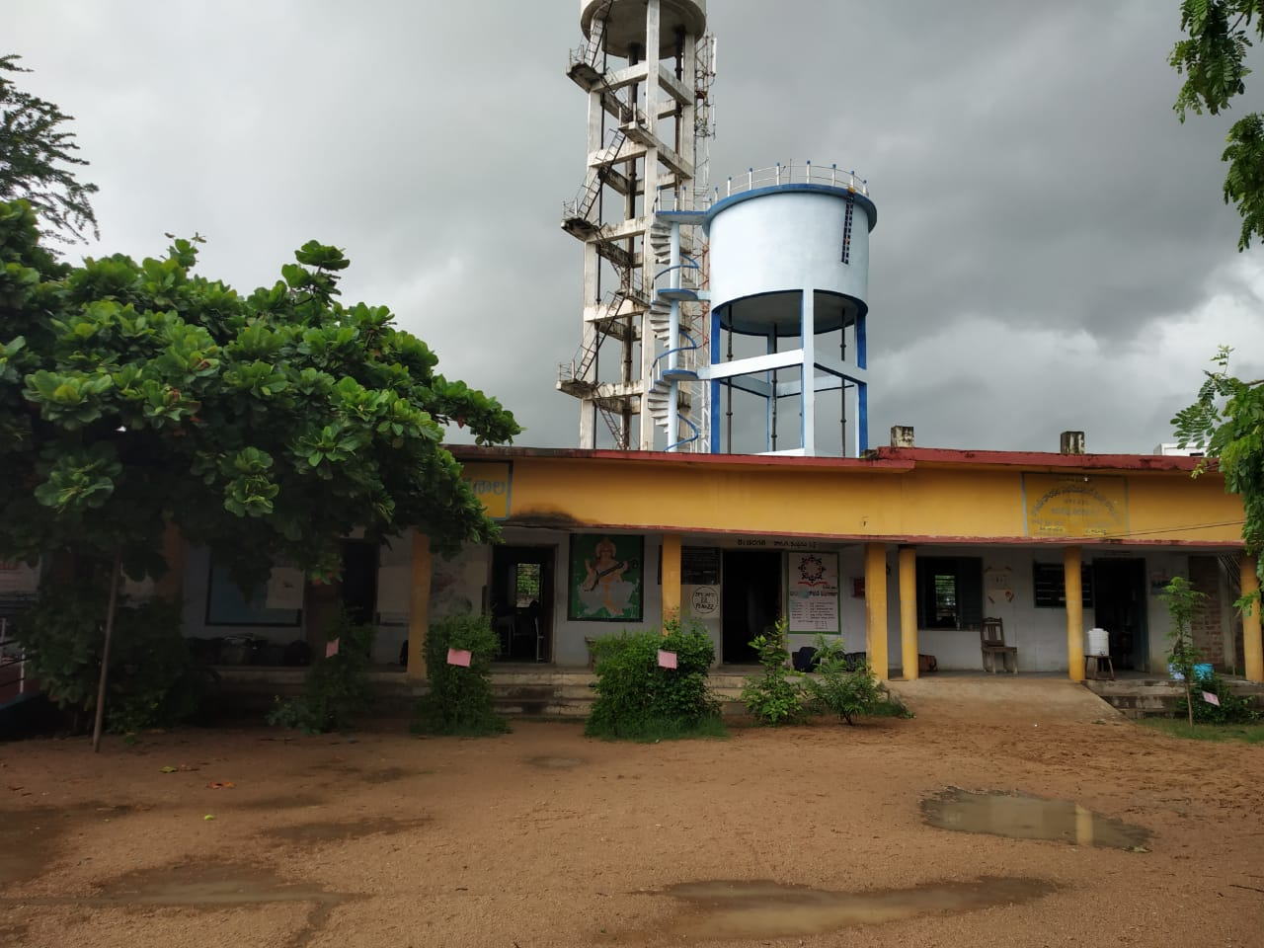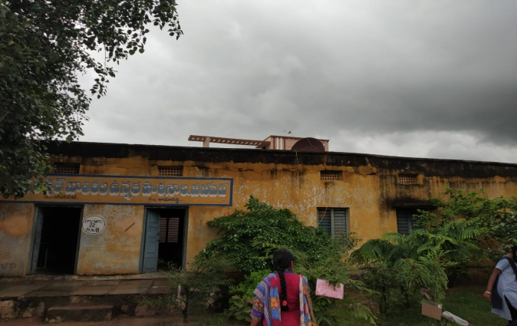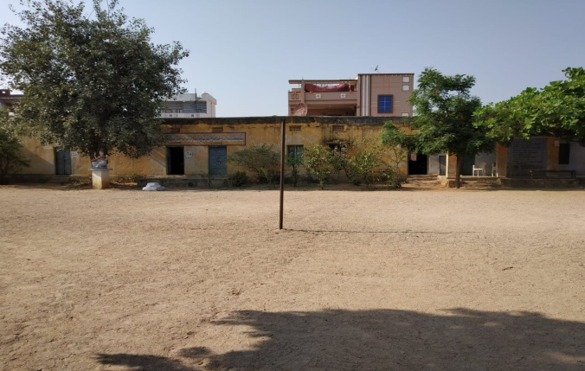

About Principal w/ photos : Now the school in administered by Smt. T.Prasanna Laxmi (M.Sc,M.Ed)FAC HM. She was appointed as School Assistant(bio.sci) on 17.10.2002 at UPS Mallupally,Mdl: Bhiknur,Dist:Kamareddy and worked for 7 years.
In 2009 she was transferred to ZPHS (boys)Kamareddy and worked for 9 years.

She was posted at ZPHS (G) Bibipet on 09/07/2018. Since then she is continuing in the same post and in same school till date.
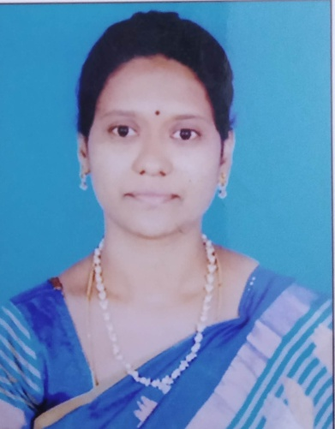

Sponsor Name :
About Sponsor w/ photos : :

Needs:

Item No # Description Priority Amount
1

Details:

Photos if needed

Item No # Description Priority Amount
2 Laptops High 20,000

Details:
Photos if needed

Item No # Description Priority Amount
3 water facility High 20,000

Details:
Photos if needed

